**Program 5: Deploy connectivity between react and node application for inventory management system**

// server.js

const express = require('express');

const bodyParser = require('body-parser');

const cors = require('cors');

const mongoose = require('mongoose');

const app = express();

const PORT = process.env.PORT || 5000;

// Middleware

app.use(bodyParser.json());

app.use(cors());

// MongoDB connection (replace 'your_connection_string' with your MongoDB connection string)

mongoose.connect('mongodb://localhost:27017/inventory-management', { useNewUrlParser: true, useUnifiedTopology: true });

const connection = mongoose.connection;

connection.once('open', () => {

  console.log('MongoDB connection established successfully');

});

// Mongoose model definition

const Schema = mongoose.Schema;

const inventorySchema = new Schema({

  name: { type: String, required: true },

  quantity: { type: Number, required: true },

});

const Inventory = mongoose.model('Inventory', inventorySchema);

// Routes

app.get('/', (req, res) => {

  res.send('Welcome to the Inventory Management System API');

});

// Route to add inventory item

app.post('/inventory/add', (req, res) => {

  const { name, quantity } = req.body;

  const newItem = new Inventory({

    name: name,

    quantity: quantity,

  });

  newItem.save()

    .then(item => res.json('Inventory item added successfully'))

    .catch(err => res.status(400).json('Error: ' + err));

});

// Start server

app.listen(PORT, () => {

  console.log(`Server is running on port ${PORT}`);

});

//App.js

import React from 'react';

import InventoryList from './components/InventoryList';

function App() {

  return (

    <div className="App">

      <InventoryList />

    </div>

  );

}

export default App;

//InventoryForm.js

import React, { useState } from 'react';

import axios from 'axios';

const InventoryForm = () => {

  const [itemName, setItemName] = useState('');

  const [itemQuantity, setItemQuantity] = useState('');

  const handleAddItem = async () => {

    try {

      // Send a POST request to the server to add the inventory item

      await axios.post('http://localhost:5000/inventory/add', {

        name: itemName,

        quantity: parseInt(itemQuantity, 10), // Convert quantity to an integer

      });

      // Clear input fields after successful addition

      setItemName('');

      setItemQuantity('');

      // Handle success, maybe show a success message or update the inventory list

    } catch (error) {

      // Handle error, show an error message or log to console

      console.error(error);

    }

  };

  return (

    <div>

      <h2>Add Inventory Item</h2>

      <label htmlFor="itemName">Item Name:</label>

      <input

        type="text"

        id="itemName"

        placeholder="Enter item name"

        value={itemName}

        onChange={(e) => setItemName(e.target.value)}

      />

      <label htmlFor="itemQuantity">Quantity:</label>

      <input

        type="number"

        id="itemQuantity"

        placeholder="Enter quantity"

        value={itemQuantity}

        onChange={(e) => setItemQuantity(e.target.value)}

      />

      <button onClick={handleAddItem}>Add Item</button>

    </div>

  );

};

export default InventoryForm;

OUTPUT

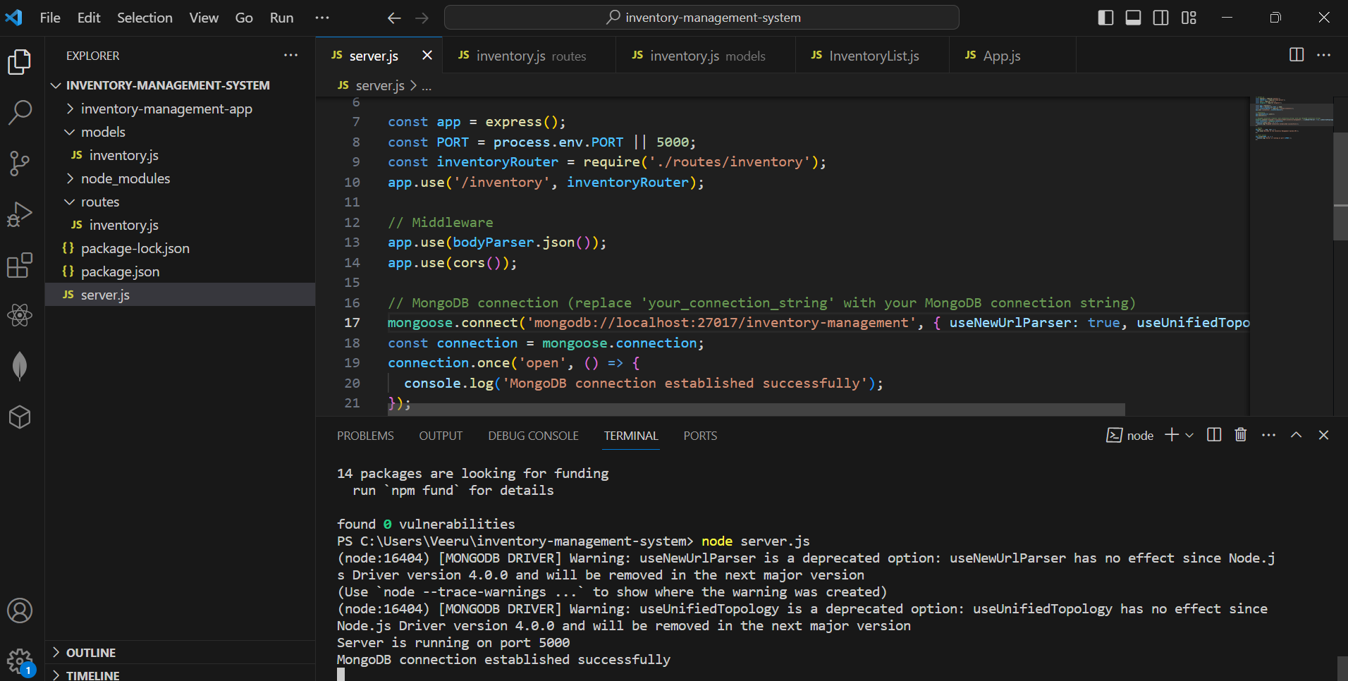

**After typing mongo in new terminal,**

This is the output as below

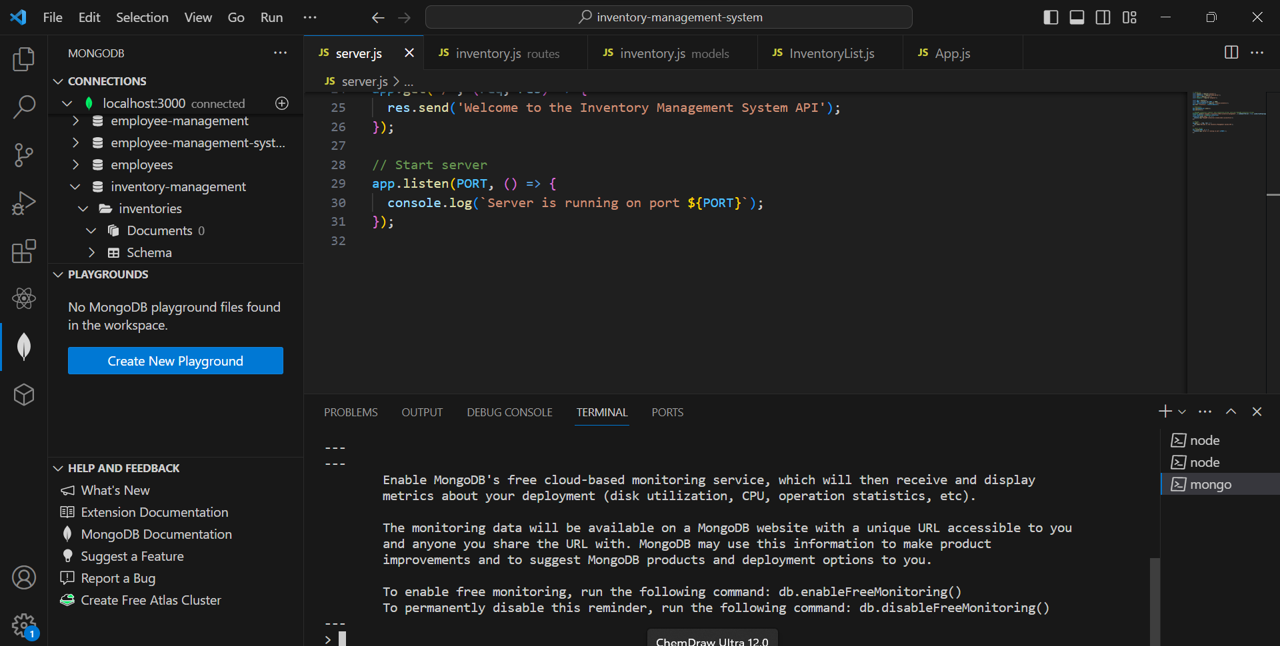

**Output for use inventories**

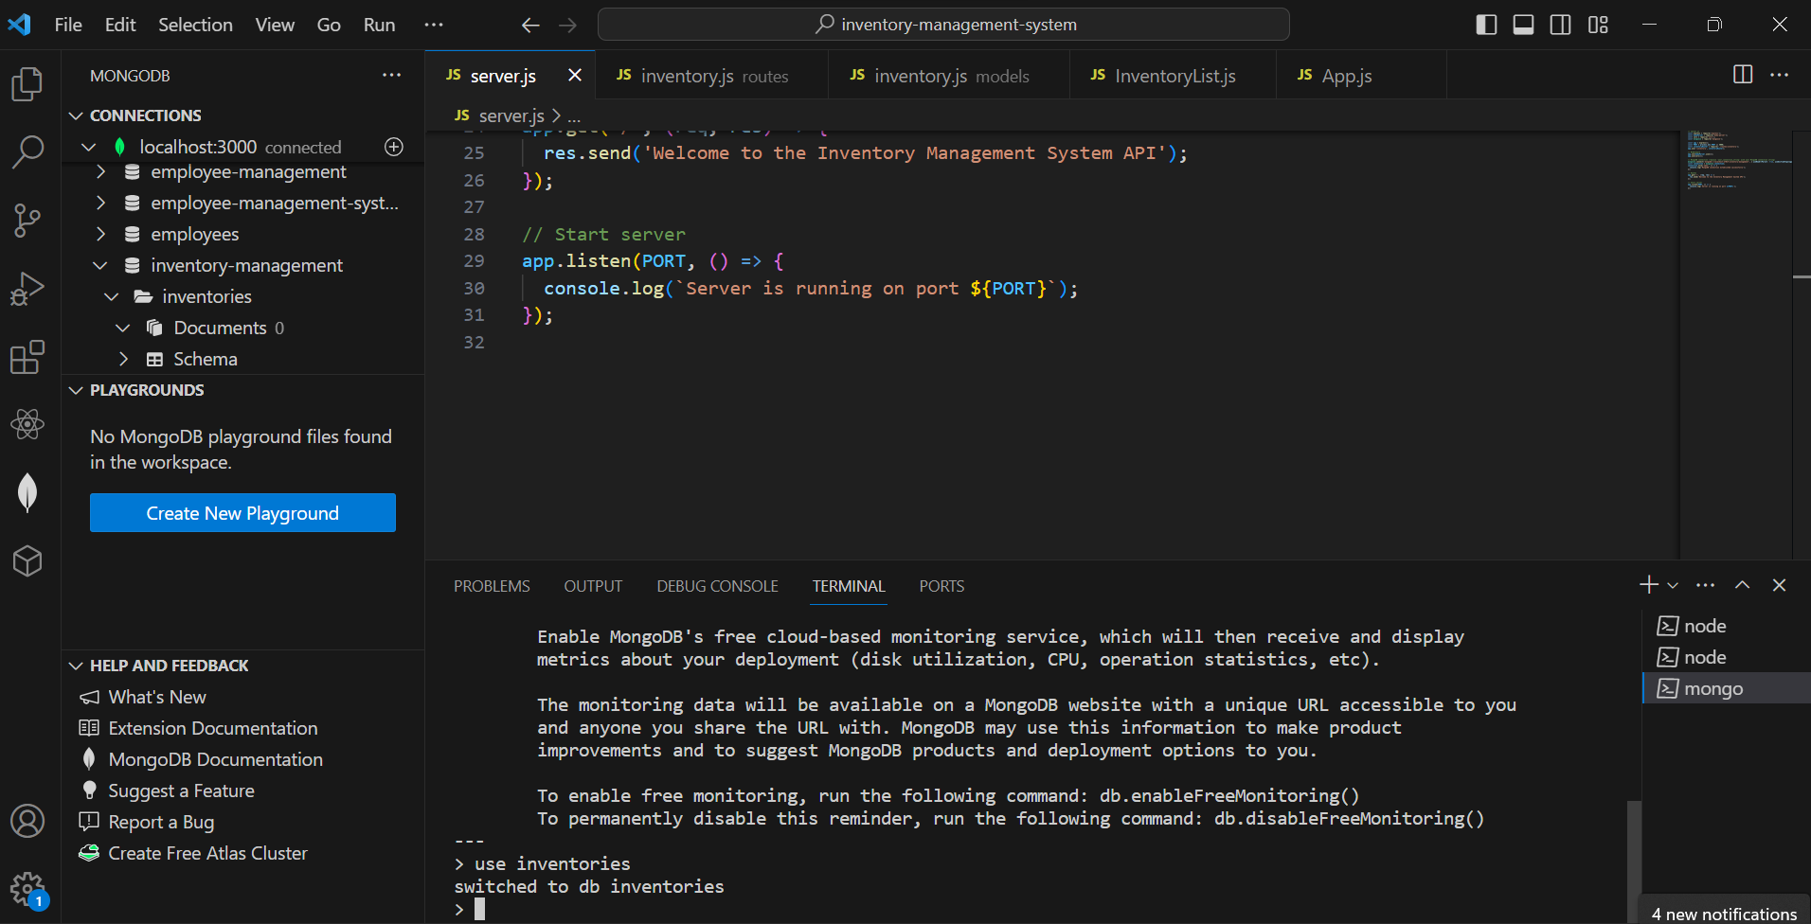

**Output for 5000**

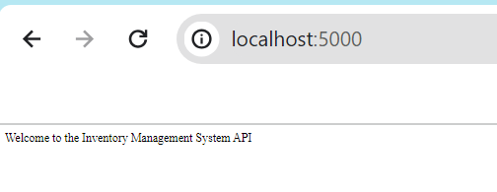

**Output** **for** **3000**

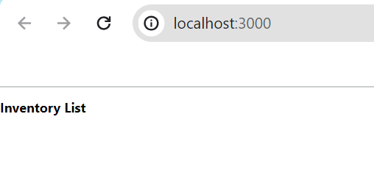

db.inventories.insertOne({ name: 'Test Item', quantity: 5 })

{

"acknowledged" : true,

"insertedId" : ObjectId("65ce3e02d9953f39fba618f5")

}

**Output for above code is**

